Module 1: Probability, Reliability and Quality
- Definition of Reliability: Understand reliability engineering as the application of scientific, engineering, statistical, and mathematical methods to reduce the likelihood or frequency and consequences of unwanted product or system behaviours. Distinguish reliability from the complete elimination of failure and recognise that reliability is evaluated under specified operating conditions and over a defined period of time.
- Fundamental Reliability Functions: Identify and interpret the cumulative probability of failure by time $t$ denoted $F\left(t\right)=P(T≤t)$ and the reliability function $R\left(t\right)=P\left(T>t\right)=1-F(t)$, where $T$ is the time to failure. Students should be able to visualise these functions and explain how the probability of failure increases, and reliability decreases, over time.
- Rated Life and Reliability-based Decisions: Understand rated life as the operating time up to which a specified minimum reliability, or maximum acceptable probability of failure, must be maintained. Students should be able to explain how rated life can inform product replacement, inspection, maintenance, and servicing decisions.
- Expressing a reliability requirement: Formulate a reliability requirement in terms of the maximum acceptable probability of failure, or minimum acceptable reliability, at a specified operating time and under a specified load or operating condition. Understand an escape as a defective or insufficiently reliable product that passes through the organisation’s quality controls and reaches a later production stage or the customer. In a reliability context, students should recognise failures occurring before the rated life as potential reliability escapes and identify why such failures require investigation.
- Failure types across the product life cycle: Distinguish between early-life, normal-life, and end-of-life failures. Students should associate early-life failures with causes such as manufacturing defects, assembly errors, or material flaws; normal-life failures with random events such as unexpected shock loads; and end-of-life failures with degradation mechanisms such as wear, corrosion, and fatigue.
- Definition of Quality: Understand quality engineering as the systematic design, control, assurance, and improvement of products and processes so that specified requirements are consistently met. Students should distinguish quality engineering from inspection alone and recognise that quality must be designed and controlled throughout the product and manufacturing life cycle. Total quality along 8 dimensions: performance, provided features, reliability, durability, conformance, serviceability, aesthetics, perceived quality.
- Turnbacks and Non-Conformance: Understand a turnback as a product, component, or process outcome that fails to satisfy an applicable quality criterion and must therefore be corrected, reworked, scrapped, or returned to an earlier stage.
- Tolerances and Yield: Understand that selected product characteristics or key performance indicators are measured and compared with upper and lower specification limits. Students should recognise the interval between the lower specification limit, (LSL), and upper specification limit, (USL), as the acceptable specification range and determine whether an individual manufactured unit conforms to the stated requirements.
Calculate and interpret the scrap rate ($\frac{\#defectives}{\#made}$) and the yield ($\frac{\#made-\#defectives}{\#made}$).
In the case of high-volume production, use the nomenclature of parts-per-million (PPM): $PPM=\frac{\#defectives}{\#made}{10}^{6}$.
- Manufacturing Outcome Distributions​: Understand that variation in manufacturing outcomes can be represented using a probability distribution fitted to measurements of a product characteristic. Students should be able to relate the position and spread of the distribution to the specification limits and identify the regions corresponding to conforming and non-conforming products. Understand short-term yield as the proportion of the fitted process distribution expected to fall within the specification limits under current process conditions.

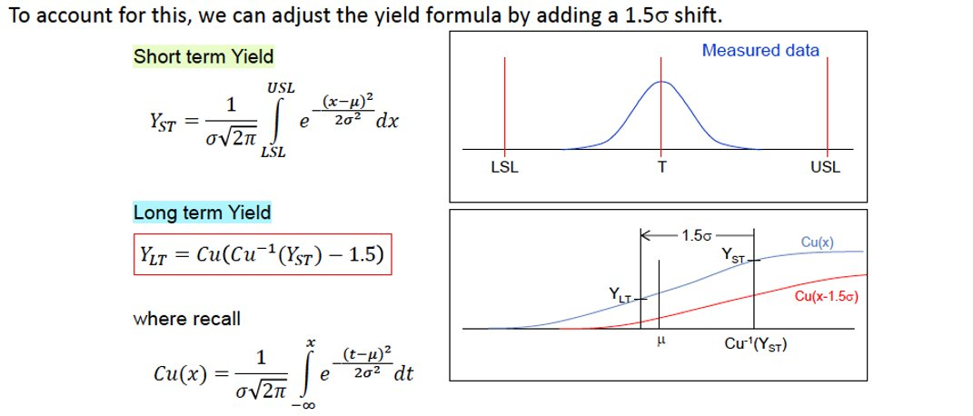
- Process Capability: Compare two approaches to preventing defective products from reaching customers: screening products through inspection and improving the underlying manufacturing process. Students should understand that 100% inspection does not necessarily guarantee zero escapes because inspection systems can produce measurement errors, false acceptances, false rejections, or missed defects.
Definitions of process potential index $C_{p}=\frac{USL-LSL}{6σ}$: continuous measure of ability to conform to a specification, understand it represents the allowable spread versus the process distribution spread.
Definitions of process capability index $C_{pk}$: continuous measure of ability to conform to a specification, accounting for mean shift. $C_{pk}=min⁡(C_{pu}, C_{pl})$ with $C_{pu}=\frac{USL-μ}{3σ}$, $C_{pl}=\frac{μ-LSL}{3σ}$.
As an indicative convention, students should recognise that values of $C_{pk}$ below (1.00) indicate that the process spread exceeds the available specification range; approximately (1.33) indicates limited or conventionally acceptable capability; approximately (1.67) indicates good capability; and approximately (2.00) indicates very high capability. Students should understand that the required threshold depends on the industry, product criticality, customer requirements, and consequences of failure.
Students should be able to read and interpret report cards such as below:
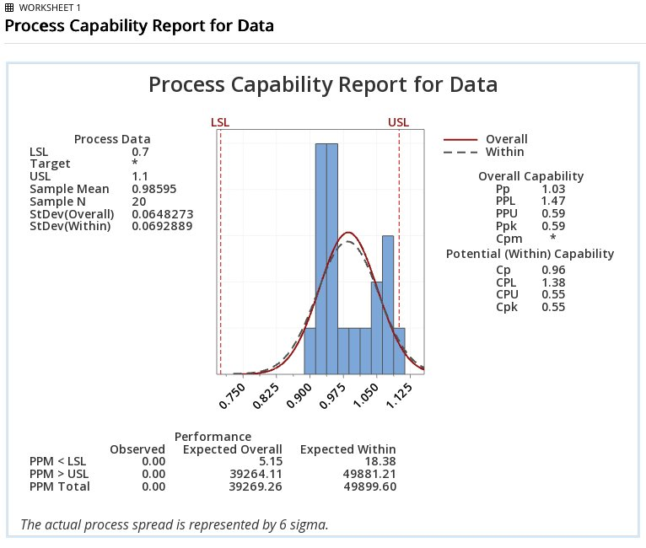
- Key Ideas: Understand that meeting specification limits does not necessarily mean that a product has high performance or provides high customer value. Quality includes both selecting appropriate performance requirements and consistently achieving them, whereas capability indices primarily evaluate how consistently a process conforms to its existing specifications. Recognise that capability indices based on short-term estimates of the process mean and standard deviation may not represent long-term production performance. Students should understand that process drift, tool wear, environmental changes, material variation, and systematic trends must be detected and controlled to maintain long-term quality.

